ASSIGNMENT NO.4: Working with Multiple Tables and Joins

Student Name | Anushka Pachpute | Roll Number | 20971
Batch | SY. BSc Data Science | Topic | WB(Assignment-4)

Q1) Create a MySQL database named CollegeDB and create the following tables:

Student Table
Column Name | Data Type | Constraint
StudentID | INT | PRIMARY KEY
StudentName | VARCHAR(50)
Column Name | Data Type | Constraint
City | VARCHAR(30)

Course Table
Column Name | Data Type | Constraint
CourseID | INT | PRIMARY KEY
CourseName | VARCHAR(50)
Fees | DECIMAL(10,2)

Enrollment Table
Column Name | Data Type | Constraint
EnrollmentID | INT | PRIMARY KEY
StudentID | INT | FOREIGN KEY
CourseID | INT | FOREIGN KEY
EnrollmentDate | DATE

QUERY:

CREATE DATABASE SeniorCollegeDB; USE SeniorCollegeDB;
CREATE TABLE Student (StudentID INT PRIMARY KEY,
StudentName VARCHAR(50), City VARCHAR(30));
CREATE TABLE Course (CourseID INT PRIMARY KEY,
CourseName VARCHAR(50), Fees DECIMAL(10,2));
CREATE TABLE Enrollment (
EnrollmentID INT PRIMARY KEY,
StudentID INT,
CourseID INT,
EnrollmentDate DATE,
FOREIGN KEY (StudentID) REFERENCES Student(StudentID),
FOREIGN KEY (CourseID) REFERENCES Course(
CourseID));

OUTPUT:
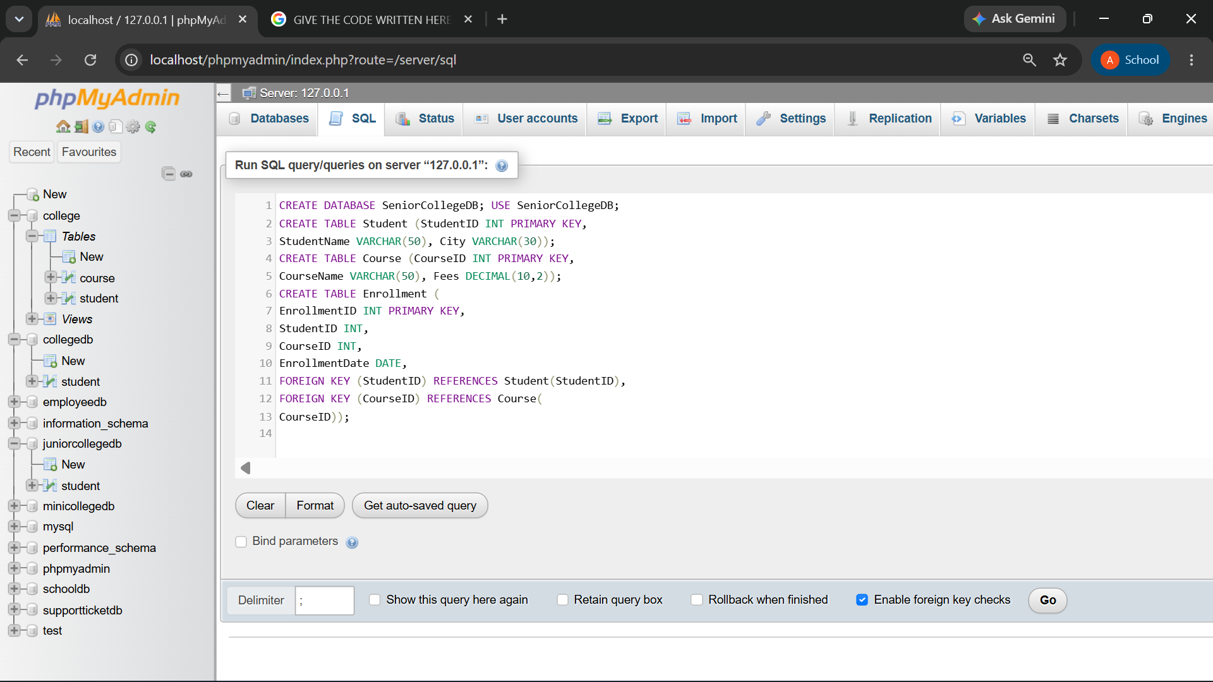
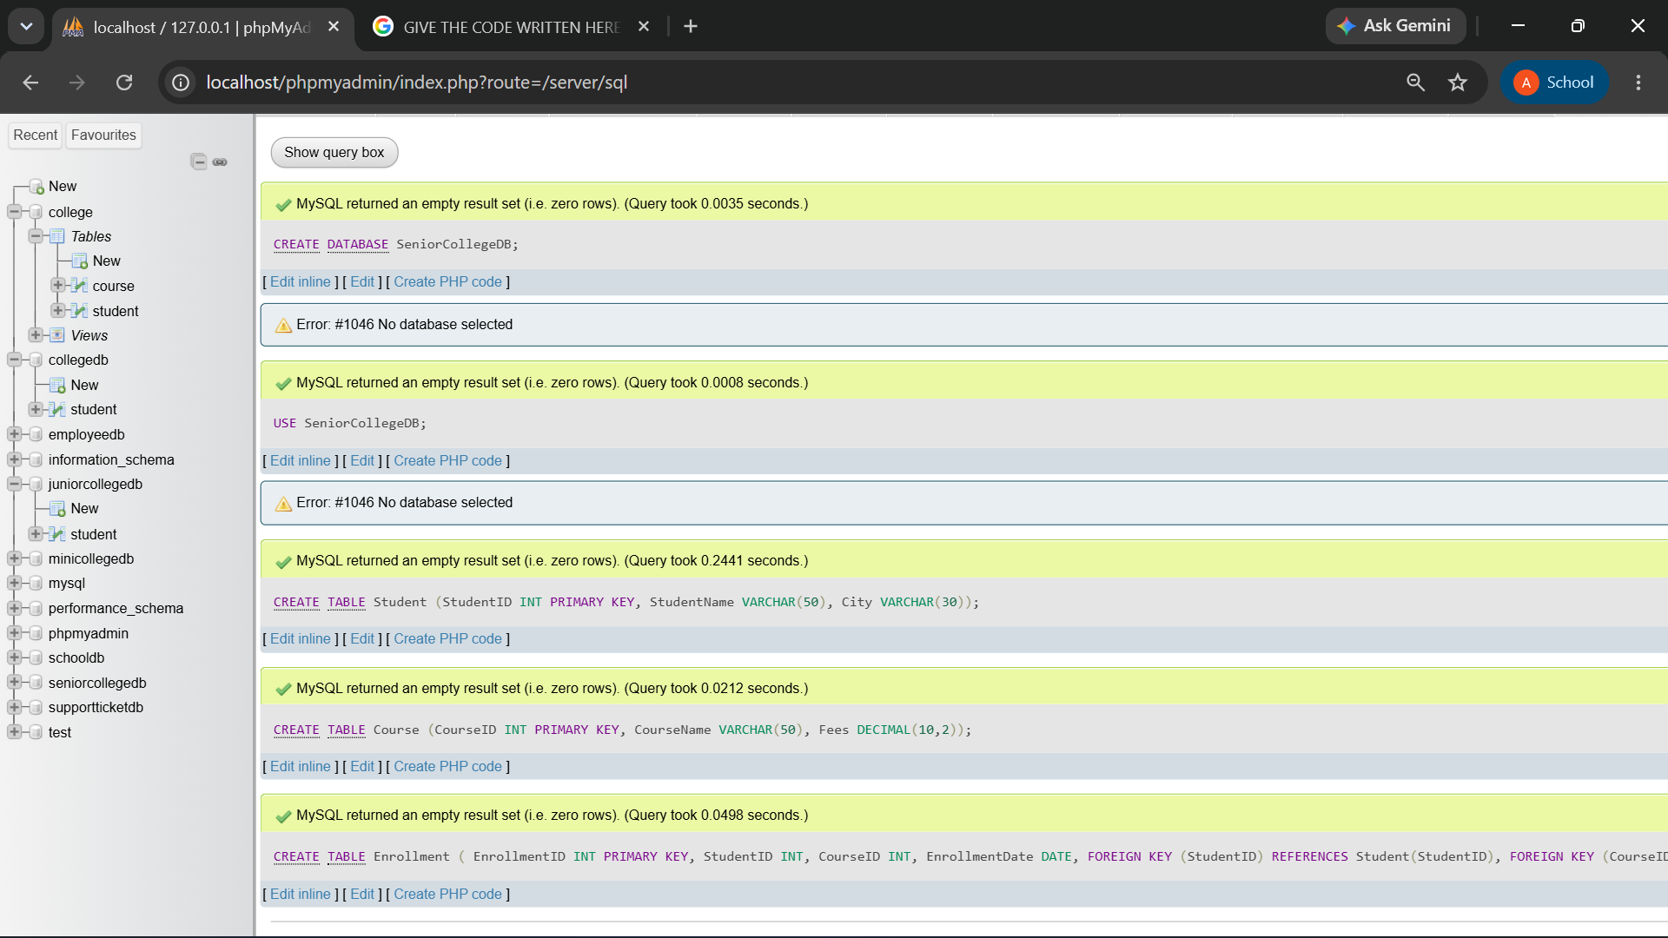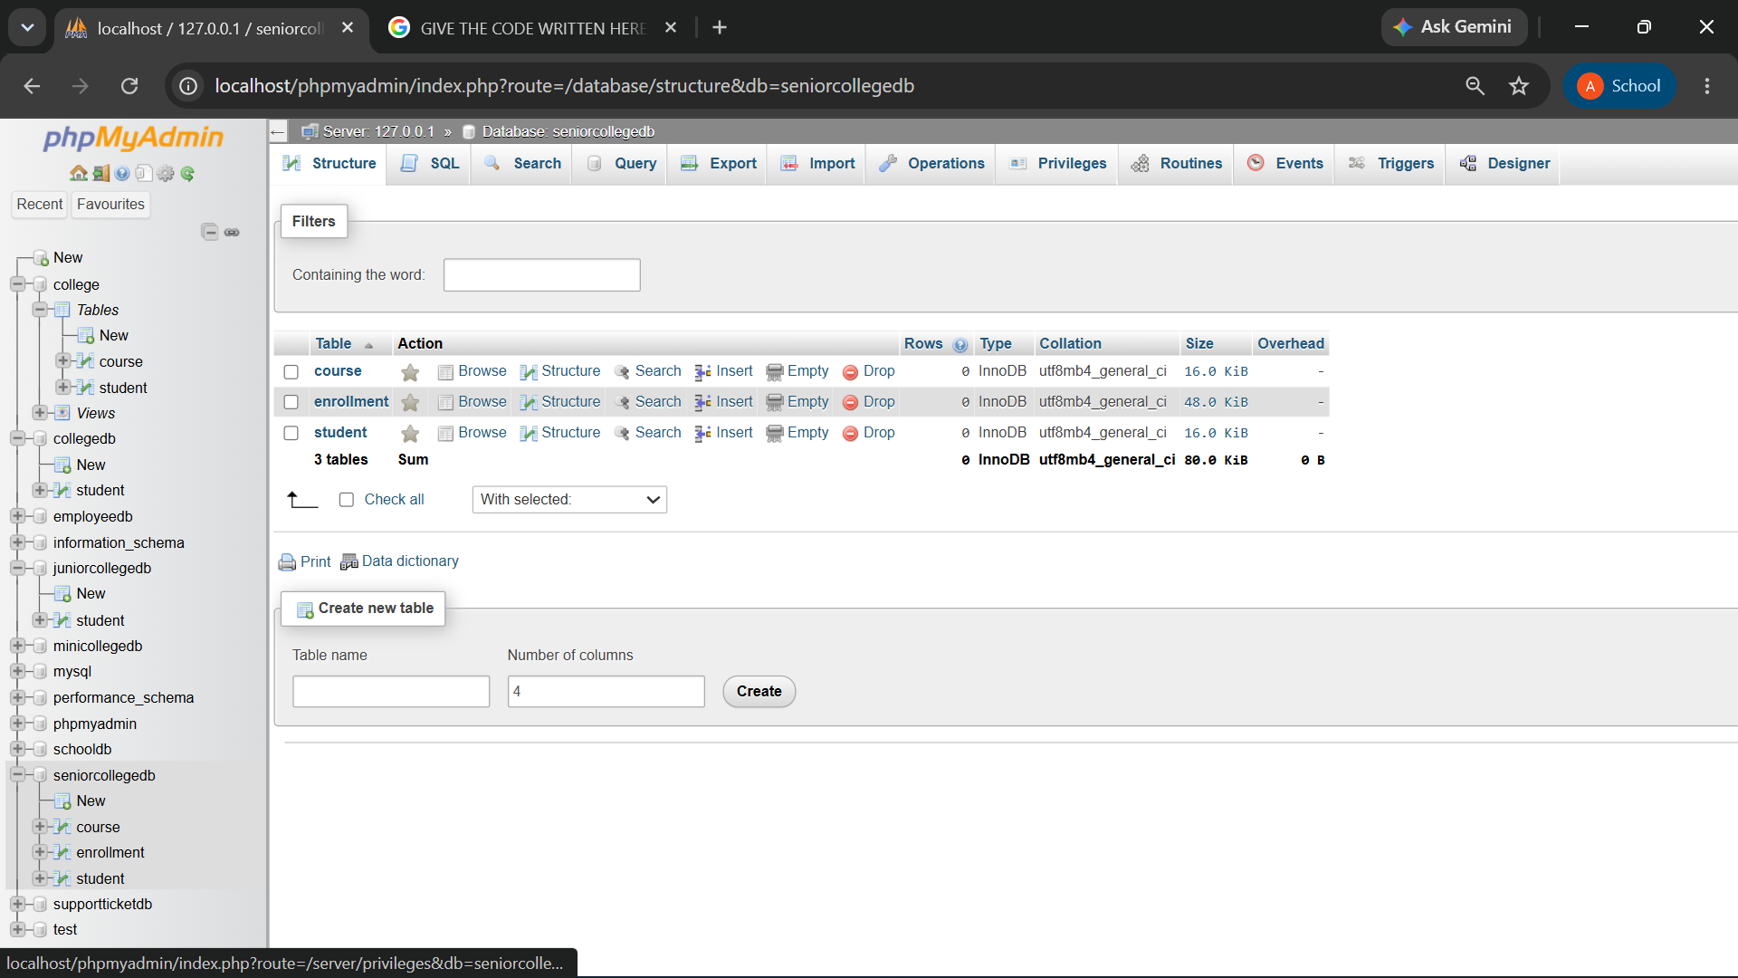

Q2) Insert at least 6 records into the Student table, 4 records into the Course table, and 5 records into the Enrollment table.
Make sure:
Requirement
At least one student should not have enrollment
At least one course should not have any enrolled student

QUERY:
-- Insert into Student table
INSERT INTO Student VALUES
(1, 'Alice', 'NY'),
(2, 'Bob', 'LA'),
(3, 'Charlie', 'SF'),
(4, 'Dave', 'CHI'),
(5, 'Eve', 'MIA'),
(6, 'Frank', 'SEA');

-- Insert into Course table
INSERT INTO Course VALUES
(101, 'Math', 500.00),
(102, 'Science', 600.00),
(103, 'Art', 300.00),
(104, 'History', 400.00);

-- Insert into Enrollment table
INSERT INTO Enrollment VALUES
(1001, 1, 101, '2023-01-01'),
(1002, 2, 101, '2023-01-02'),
(1003, 3, 102, '2023-01-03'),
(1004, 4, 103, '2023-01-04'),
(1005, 5, 103, '2023-01-05');

OUTPUT:
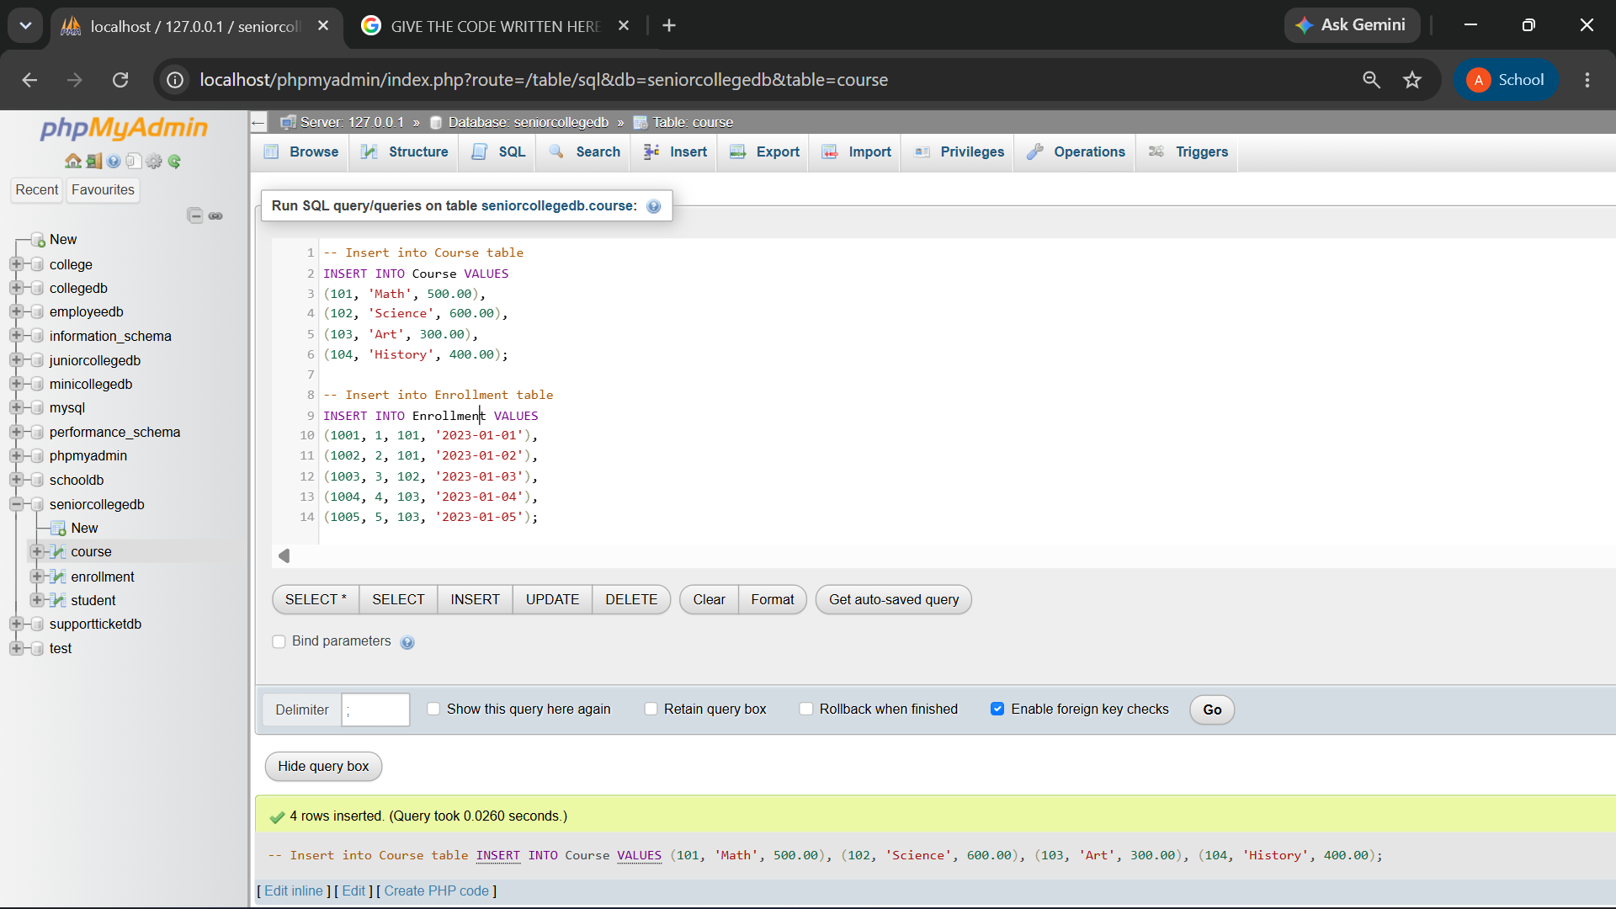

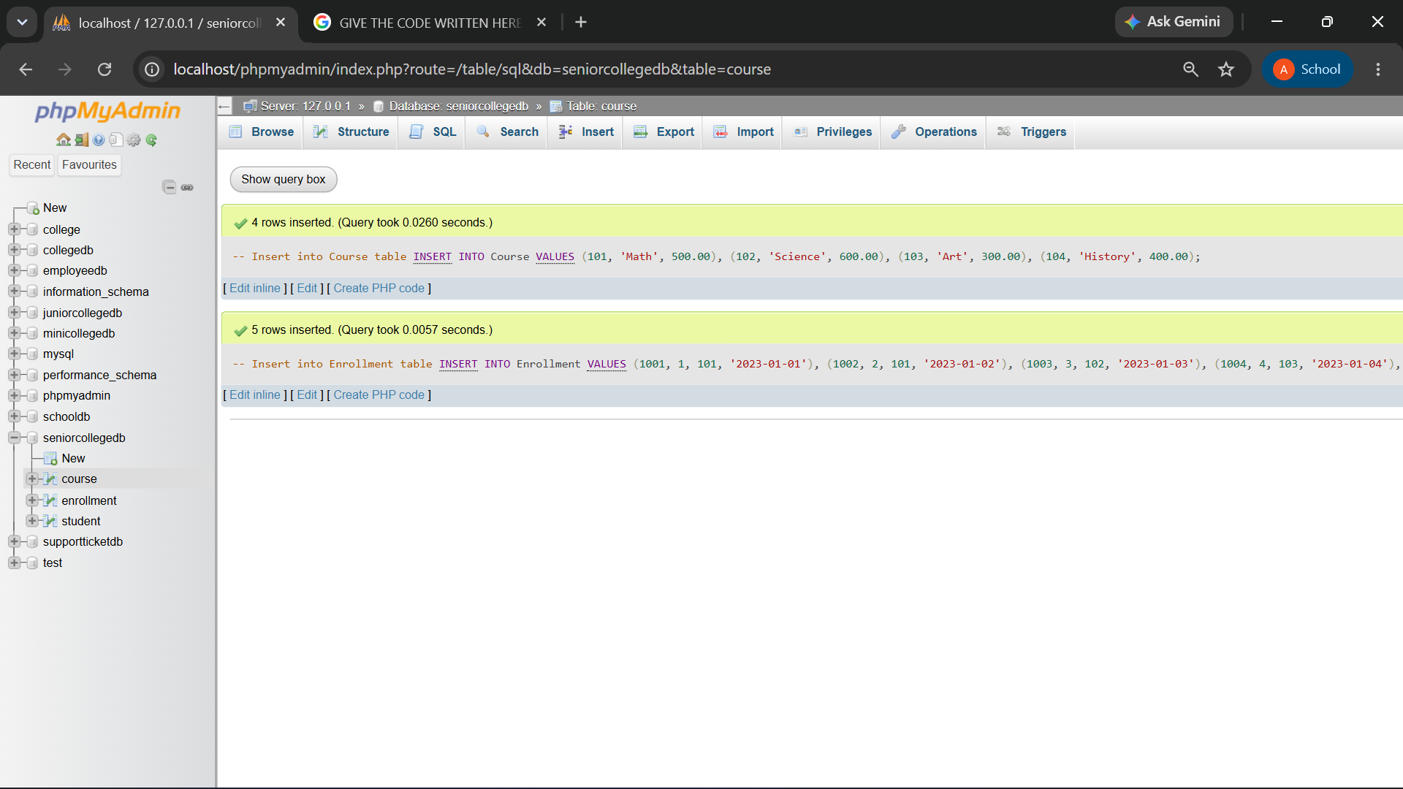

Q3) Write a MySQL query using INNER JOIN to display students who have enrolled in courses.

The output should include:
Column
StudentID
StudentName
CourseID
EnrollmentDate

QUERY:
SELECT student.StudentID,student.StudentName,enrollment.CourseID,enrollment.EnrollmentDate
FROM student
INNER JOIN enrollment ON
student.StudentID = enrollment.StudentID;

OUTPUT:
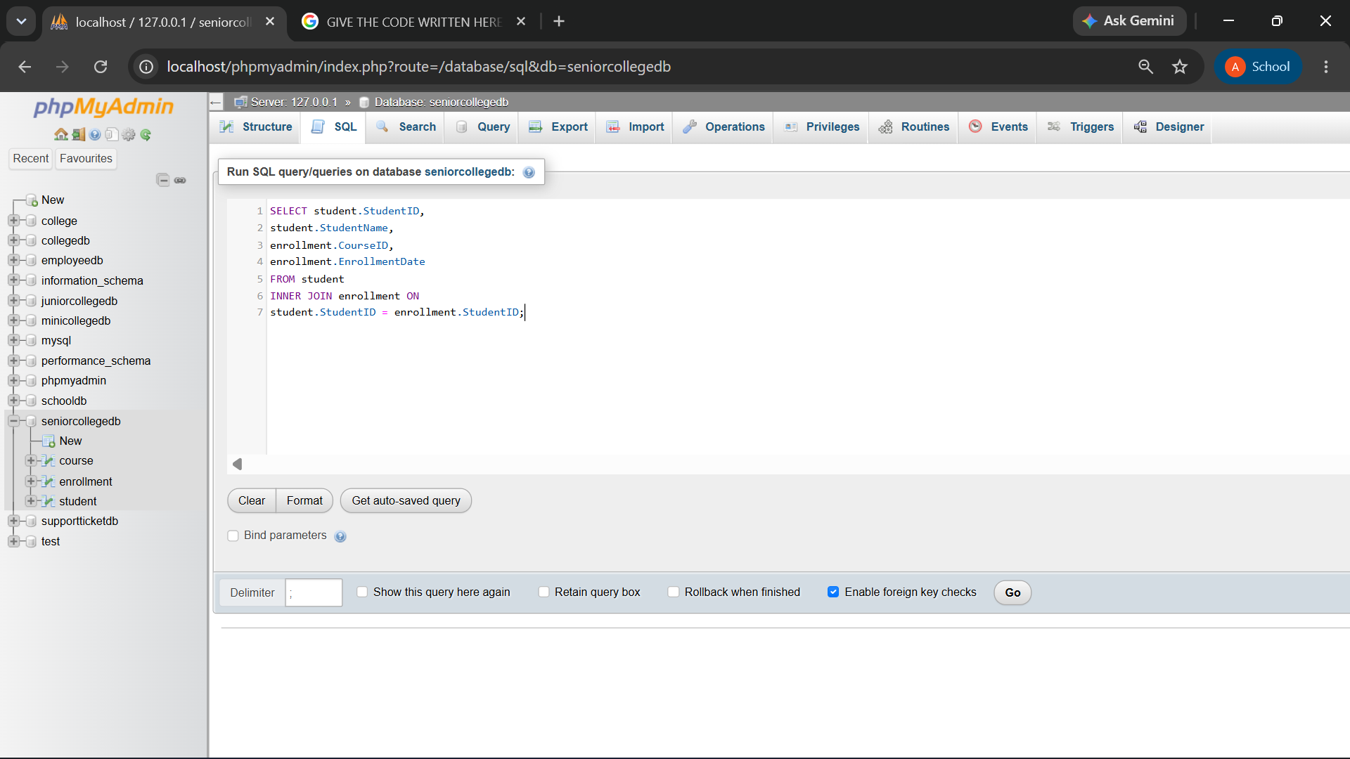
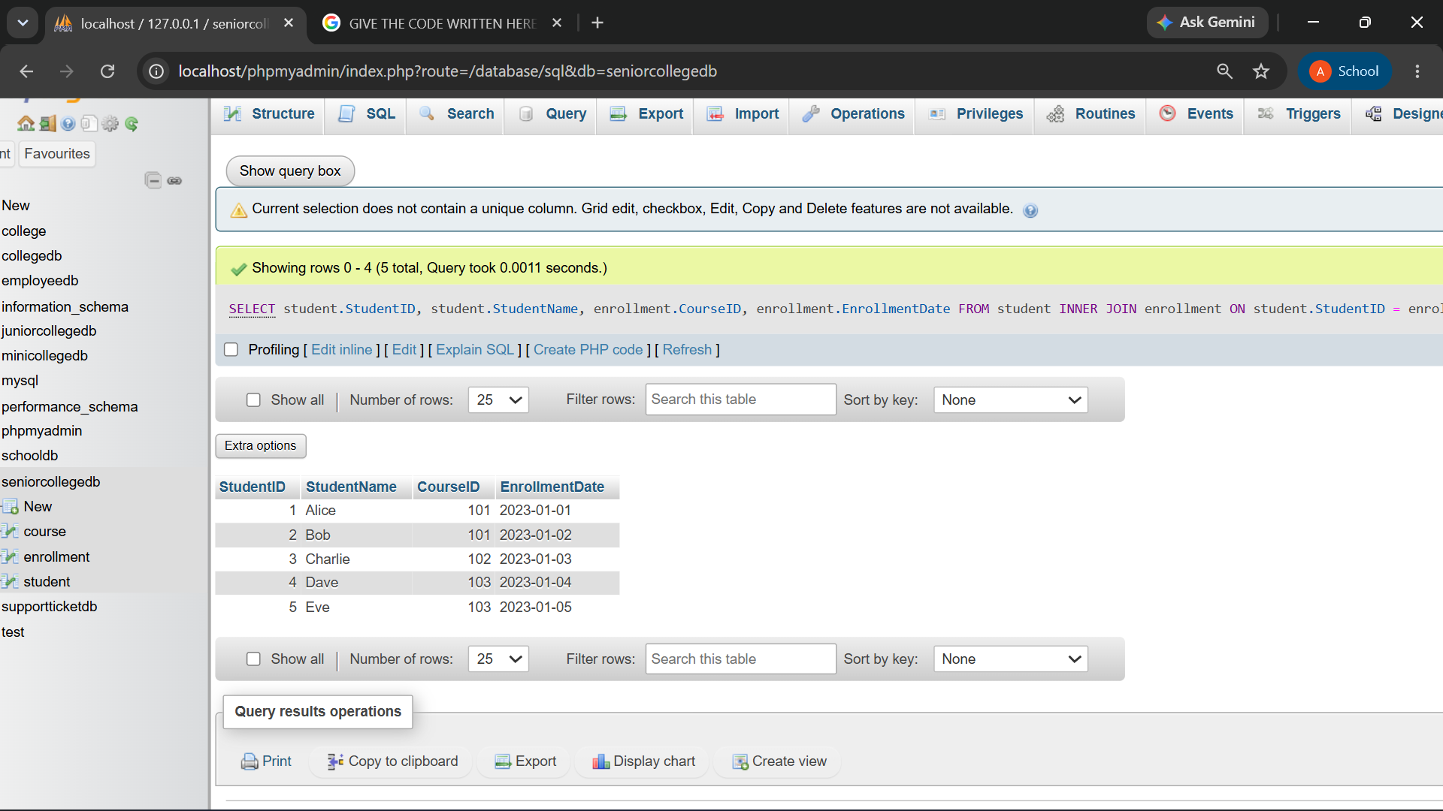

Q4) Write a MySQL query to display student name, city, course name, fees, and enrollment date using multiple tables.
Use:
Tables Required
Student
Course
Enrollment

QUERY:
SELECT Student.StudentName,Student.City,Course.CourseName,Course.Fees,Enrollment.EnrollmentDate
FROM student
JOIN Enrollment ON
Student.StudentID = Enrollment.StudentID
JOIN Course ON Enrollment.CourseID = Course.CourseID;

OUTPUT:
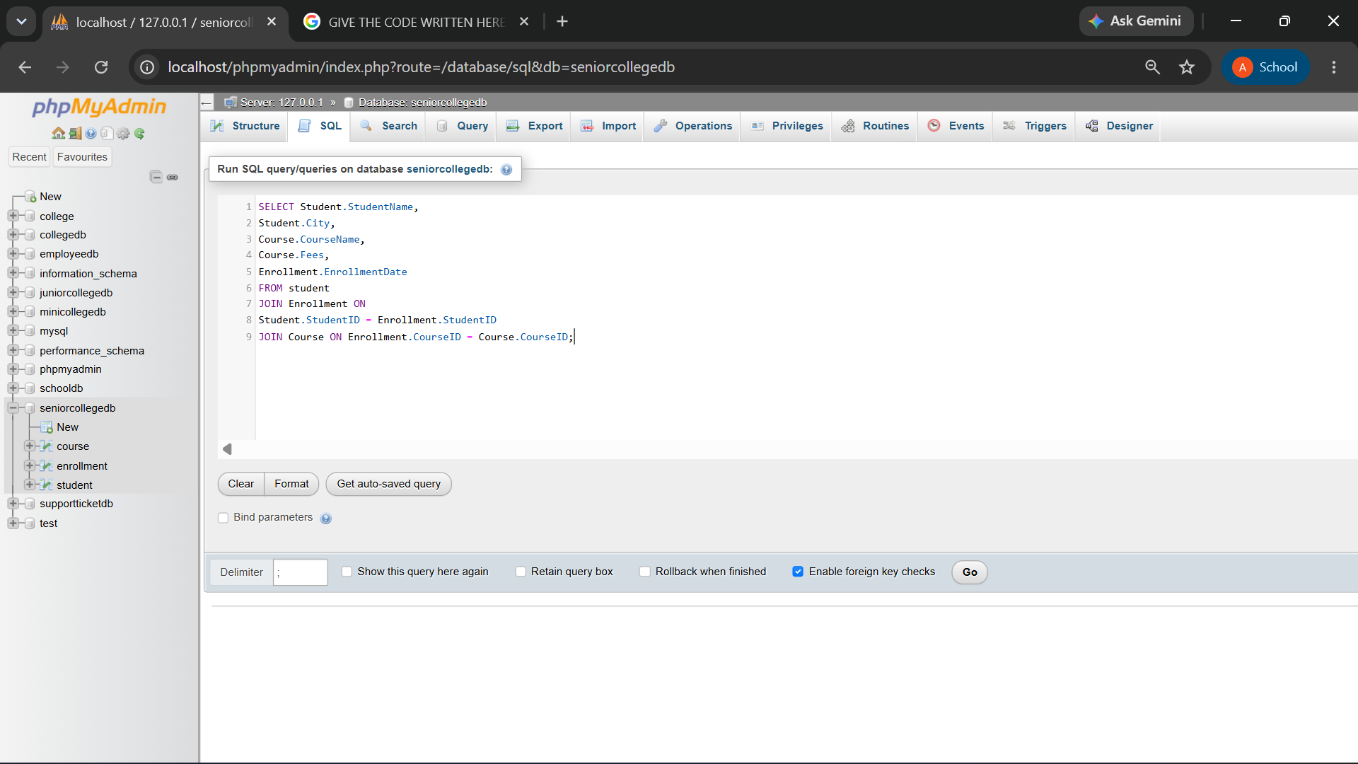
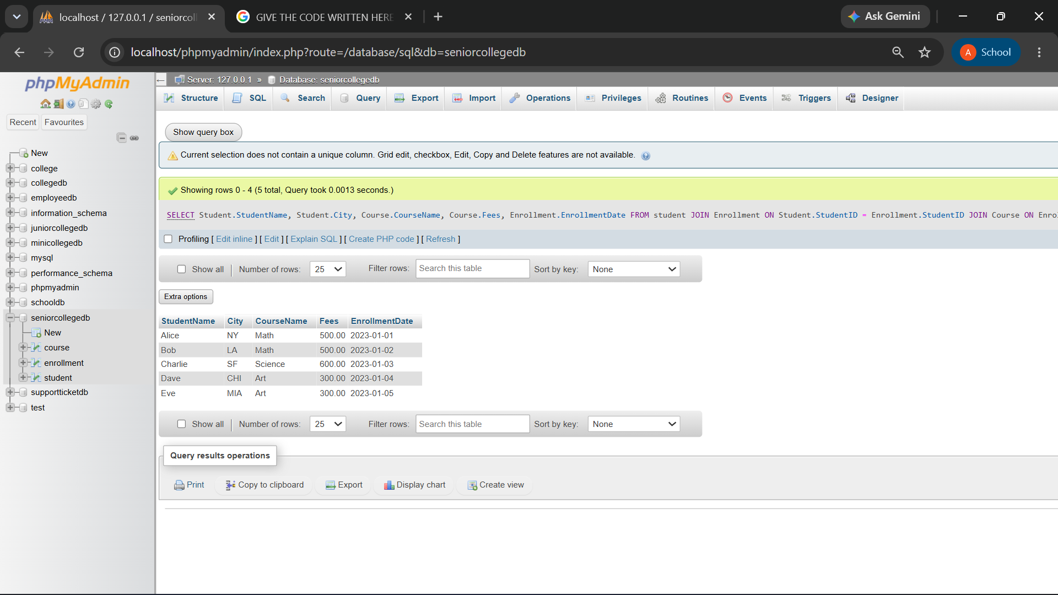

Q5) Write a MySQL query using LEFT JOIN to display all students, including those who have not enrolled in any course.
The output should include:
Column
StudentID
StudentName
City
CourseID
EnrollmentDate

QUERY:
SELECT Student.StudentID, Student.StudentName, Student.City,Enrollment.CourseID,
Enrollment.EnrollmentDate
FROM Student
LEFT JOIN Enrollment
ON Student.StudentID = Enrollment.StudentID;

OUTPUT:
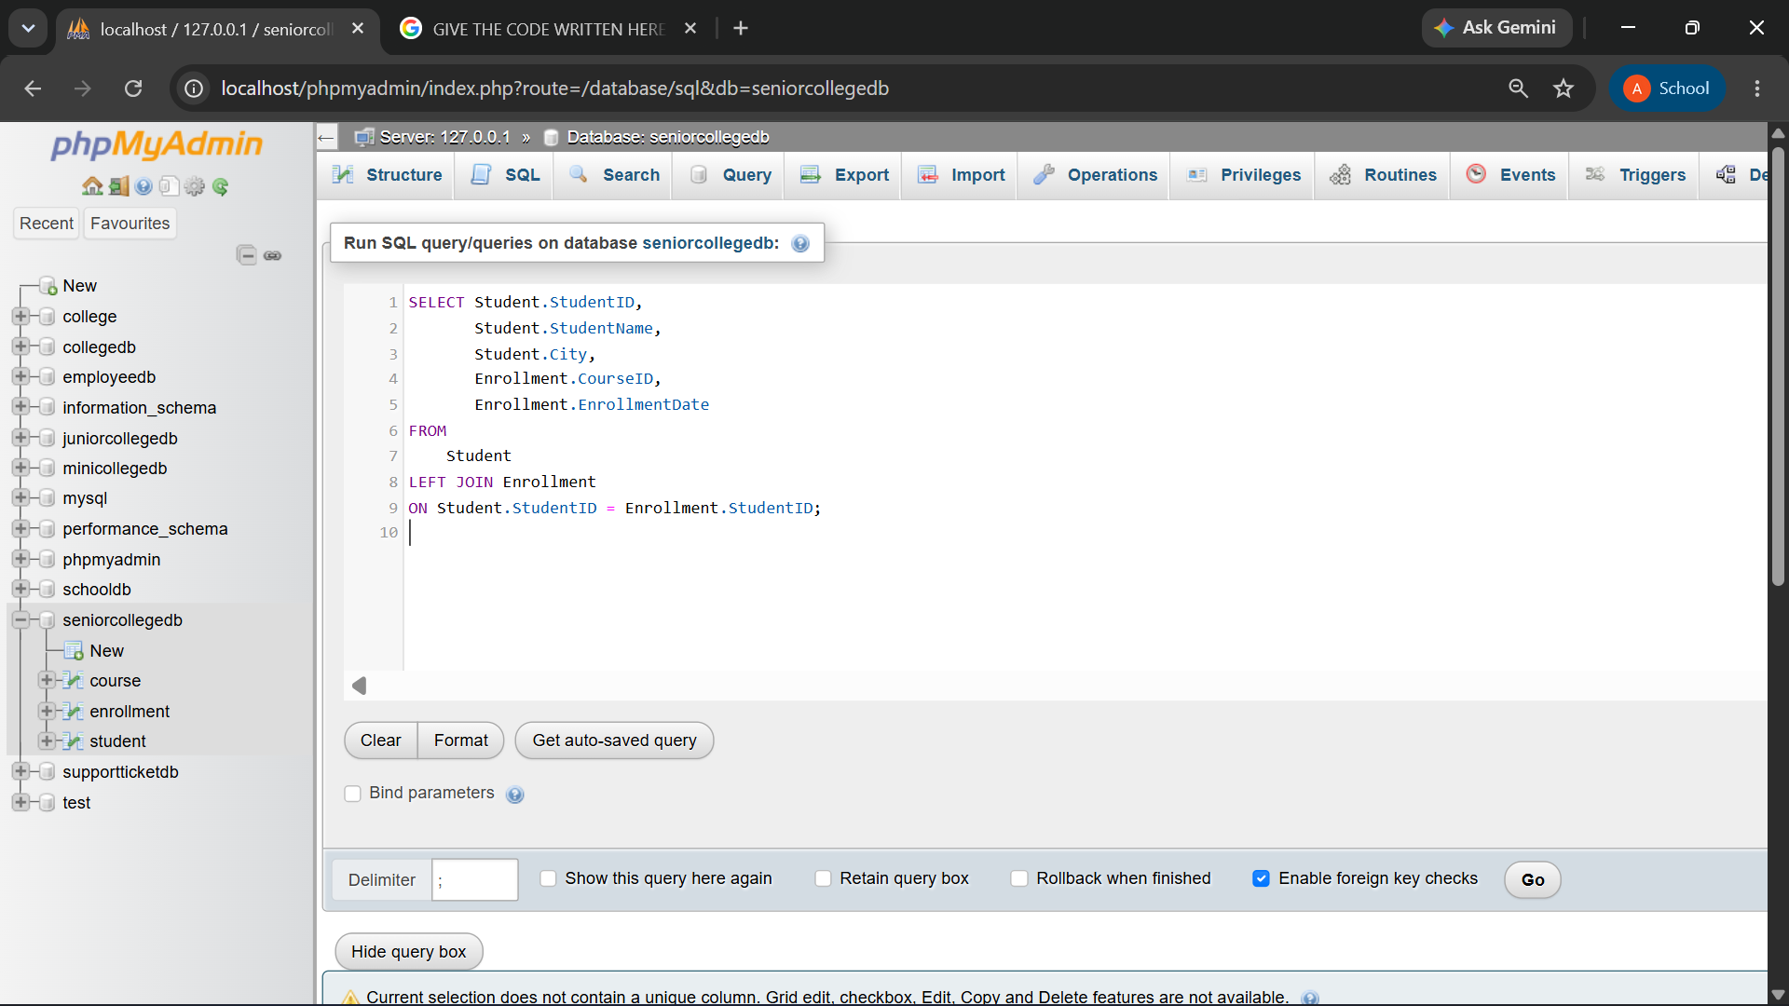
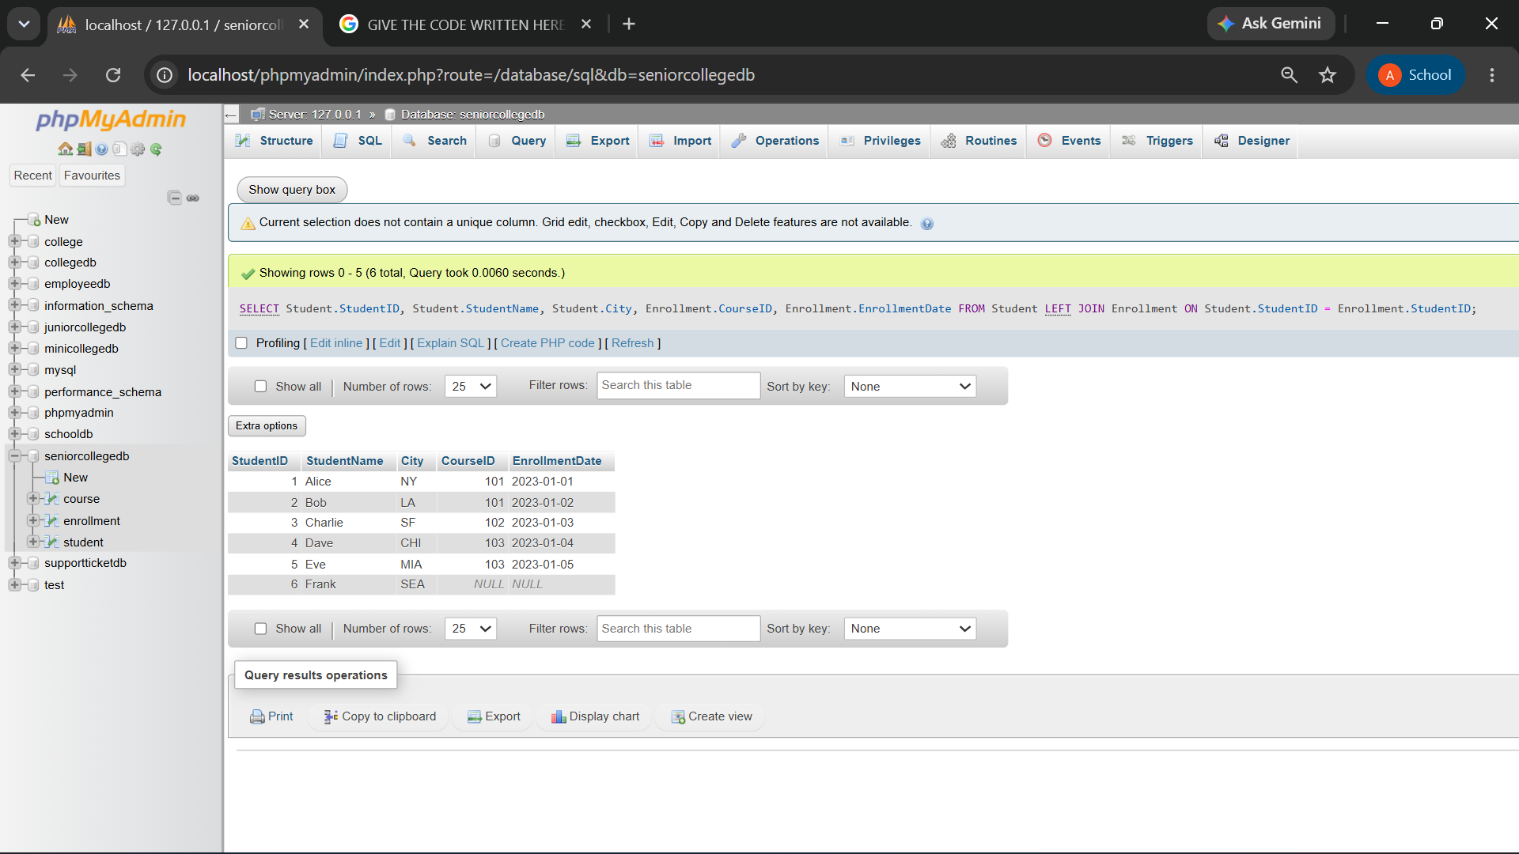

Q6) Write a MySQL query using RIGHT JOIN to display all courses, including courses that have no enrolled students.
The output should include:
Column
StudentName
CourseID
CourseName
Fees

QUERY:
SELECT Student.StudentName,Course.CourseID, Course.CourseName, Course.Fees
FROM Student
JOIN Enrollment ON
Student.StudentID = Enrollment.StudentID
RIGHT JOIN Course ON
Enrollment.CourseID = Course.CourseID;

OUTPUT:
